Top of Form

Build a Treemap

Use treemaps to display data in nested rectangles. You use dimensions to define the structure of the treemap, and measures to define the size or color of the individual rectangles. Treemaps are a relatively simple data visualization that can provide insight in a visually attractive format.

The basic building blocks for a treemap are as follows:

|  |  |
| --- | --- |
| **Mark type**: | Automatic or Square |
| **Color**: | Dimension or Measure |
| **Size** | Measure |
| **Label** or **Detail**: | Dimension(s) |

To create a treemap that shows aggregated sales totals across a range of product categories, follow the steps below.

1. Connect to the **Sample - Superstore** data source.
2. Drag the **Sub-Category** dimension to **Columns**.

A horizontal axis appears, which shows product categories.

1. Drag the **Sales** measure to **Rows**.

Tableau aggregates the measure as a sum and creates a vertical axis.

Tableau displays a bar chart—the default chart type when there is a dimension on the **Columns** shelf and a measure on the **Rows**shelf.

1. Click **Show Me** on the toolbar, then select the treemap chart type.

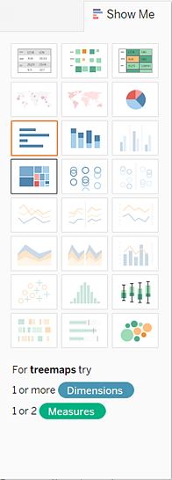

Tableau displays the following treemap:

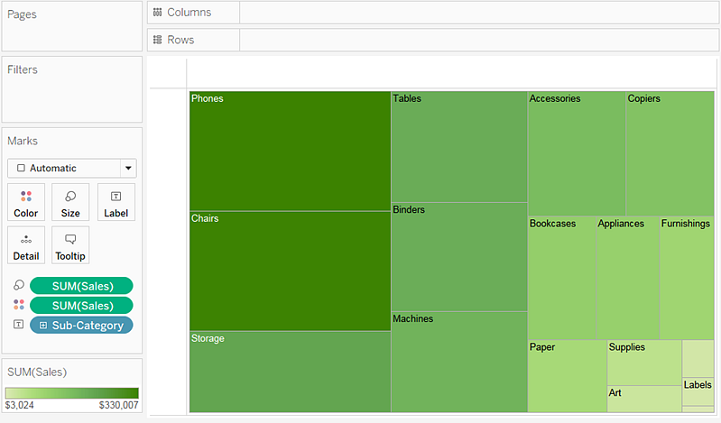

In this treemap, both the size of the rectangles and their color are determined by the value of **Sales**—the greater the sum of sales for each category, the darker and larger its box.

1. Drag the **Ship Mode** dimension to **Color** on the **Marks** card. In the resulting view, **Ship Mode** determines the color of the rectangles—and sorts them into four separate areas accordingly. **Sales** determines the size of the rectangles:

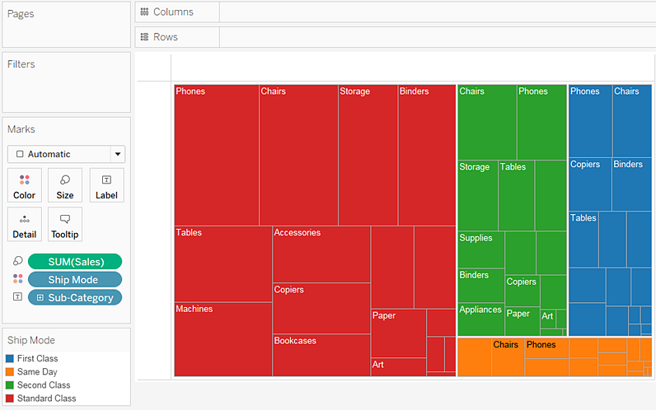

1. Try another option to modify the treemap: click the **Undo** button to remove **Ship Mode** from view.
2. Drag the **Profit** measure to **Color** on the **Marks** card. Now **Profit** determines the color of the rectangles, and **Sales** determines their size:

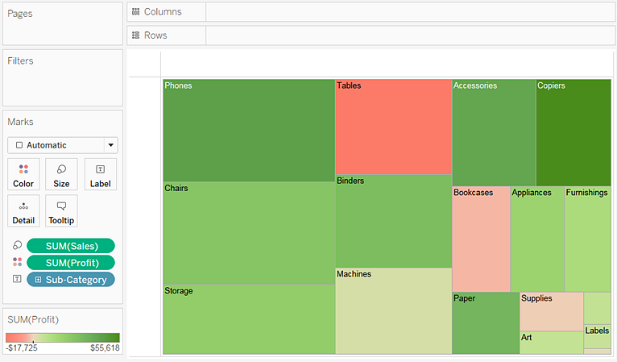

With treemaps, **Size** and **Color** are the crucial elements. You can place measures on **Size** and **Color**, but placing a measure anywhere else has no effect. Treemaps can accommodate any number of dimensions, including one or even two on **Color**. But beyond that, adding dimensions only breaks the map into an ever greater number of smaller rectangles. For information on how to place two dimensions on **Color** in a treemap, see [Example – Multiple Fields on Color](http://onlinehelp.tableau.com/current/pro/desktop/en-us/viewparts_marks_markproperties_color_ex1.html).